Date: November 16th, 2017
- Call to Order
John Shardlow called the meeting to order at 7:13pm.
- Devotional / Shared Prayer
Pastor Sara led us in prayer.
- Establish a Quorum
So noted
  - Members present: John Shardlow, Mike Dolan, Darci Bontrager, Beth Jacobson, Keith Gilbert, Jessie Henry
  - Members absent: Jeff Johnson, Joe Zeigler, Tom Lund
  - Others present: Pastor Lauren Wrightsman, Pastor Sara Spohr, Laurel Hofeldt, Dave Booms, Michael Jordan
- Approval of Agenda
A motion to approve the agenda was made by Beth, seconded by Jessie and approved unanimously.
- Approval of October minutes
A motion to approve minutes was made by Mike, seconded by Beth and approved unanimously.
- Monthly Reports
Reports are attached; additional discussion is listed below as expressed.
  - Finance: Laurel
A motion to approve the updated ethics policy was moved by Beth and seconded by Jessie. The motion was approved unanimously.
  - Staff
      - Pastors
        - Senior Pastor
          - Welcome new Visitation Pastor
Pastor Dick is leaving at the end of the year. There will be a gift for him and recognition of his service to the church coming up. Pastor Rolf Olson was offered the position and he accepted.
          - Stewardship Update
Meeting next week.
          - Innovations in Management
        - Associate Pastor
M/O is coming along; a presentation will be along in December or January.
The confirmation retreats are a great success for kids and leaders bonding.

      - Church Administrator
Help was requested of Council to keep congregants moving along during the church service Sunday. There will be more discussion on long term strategic planning for facility improvements, identifying leaders for a committee.
  - Committee Reports
    - Mission & Outreach- Darcy
    - Stewardship- Keith
    - Children- Joe
    - Youth & Family- Jessie
The committee is updating behavioral, scholarship and other policies to improve structure and document knowledge. Mentors will be needed during Lent for 9th grade Confirmation students. MEA getaway a great success. Unplugging adults and students helpful, allowing those going to get to know each other.
    - Adult Ed- Beth
Planning far in advance done for the coming year and beyond.
    - Christian Life- Beth
Bowling event upcoming. The swing dance was well attended. Perhaps a New Year’s event, followed by a dinner event in January.
    - Nominating- Mike Tom
    - Task Force Updates
      - Strategic Planning:
        - Mission and Outreach Taskforce update
        - Facilities and maintenance task force
Some initial interest; suggest Julie or another person she has in mind.
      - 75th Anniversary
- Items for Discussion
  - Comments about Council facility tour
A special offering at 75th event to help fund roof will take place. Memorial gifts could be used but further discussion needs to take place. The tour by Steve Henry was helpful in seeing areas on the campus in need of repair, especially multiple water issues from roof areas. Steve was encouraged to continue obtaining estimates. Council agreed that work should commence as soon as the weather allows.
- New Business (Action Items)
  - Endowment committee grant selections from October
After general discussion, a motion to approve the Endowment committee selections for October was made by Mike and seconded by Jessie. The motion was approved unanimously.
- Upcoming dates
  - December 14th proposed meeting date for Council, one week early to avoid Christmas week.
- Adjournment
- Closing Prayer
The Council was led by the Pastors in the Lord’s Prayer.

Respectfully submitted,
Mike Dolan
Council Vice President
Roseville Lutheran Church

Council Report
Senior Pastor, Lauren Wrightsman
November 15, 2017

- Action Items in Progress / Pending

  - Innovations in Management: Over 30 people participated in the one-on-one sessions with Bruce Matza and Dan Haupt from Innovations in Management. I thank all of those who took the time to meet with them.

Members of council and other lay leaders who weren’t part of the interviews were asked to participate in an email survey. Twelve out of 30 responded to the email.

All responses are being processed by Innovations in Management. Our next steps are:
        - Meet with Executive committee, pastors and Innovations in Management. This team will go over the responses and decide on how to move forward.
        - Team sessions will be facilitated with council and lay leaders to discuss the findings and how this best fits into our strategic planning. These dates will, most likely, occur in January 2018

  - 75th Anniversary celebration: We are ready for the big day on Sunday, November 19th. The Anniversary Task Force has done a wonderful job of facilitating needs and ideas. John Helgen and others on the music staff has worked diligently on preparing the choirs and other players. Please join us and remember to wear your council nametag on that date!

  - Direction for the Strategic Planning:
Innovations in Management: in process

Worship and Music Task force
Tabled - Pastor Lauren, Pastor Sara, and John Helgen are meeting in December to brainstorm the ways in which we worship at RLC.

  - Personnel Policy: In process. Will be brought forward at the January council meeting.

  - Congratulations to Connie and Steve on our fully licensed kitchen! (Please see Dave Booms’ notes about this!

Budget Requirements (if any)
None

- Action Items Completed

Budget Requirements (if any): None

- Questions for the council to address. Do any require council vote? (Yes or No)

None

- Other comments

Council Report
Staff Member name: Sara Spohr
Date: November 2017

1) Action Items in Progress / Pending
• Mission and Outreach task force - The task force continues to meet, there is
energy and vision for what we have been asked to do. We are getting excited to
share it with you. We think that we will very likely be ready to present something
to you at the December meeting, we are requesting 30 minutes in the December
or January agenda for our presentation.

• Lenten Devotional - I am continuing to work on putting together a daily devotional
for the season of Lent. A variety of our Roseville Lutheran Church members have
agreed to write, I’m thankful so for so many people who willingly agreed to work
on this project. I am really excited about getting more and more people an
opportunity to read God’s word daily.

• The Youth and Family Team has been working diligently on some new and updated
policy statements, these include statements on behavior, transgender youth,
mental health, and distribution of scholarship funds. This is a very dedicated team
and they have been thinking very carefully about these topics. I think this work
will make our programs for children, youth and their families even stronger and
continue to ensure a high level of safety and inclusion for our kids and their
friends.

Budget Requirements (if any)

2) Action Items Completed
• Our 7th and 8th grade youth, along with great adult leaders and some of our high
school leadership team just returned from a confirmation retreat Wapo Lutheran
Bible Camp. Thanks to the council’s budgetary support of this program we were
able to offer this camp free of charge to our students. It was worth it. This time
away provided some excellent chances for youth to bond with each other, their
leaders and our high school youth leaders. They learned, they participated in
team building activities, they worshiped and they just had fun.
Budget Requirements (if any)

3) Questions for the council to address. Do any require council vote? (Yes or No)

4) Other comments

Staff Member name: Dave Booms-Church Administrator

Date: 11/09/17

- New items
  - Building and Grounds
    - Glass Repair
    - Door Repair
    - Painting
  - Design Team
    - November notes: see below
    - Working with Staff on 75th Anniversary displays
  - Communications
    - No New items
  - Hospitality
    - We are now a fully licensed kitchen!
      - Inspector indicated we had one of the cleanest kitchens in the metro area. No infractions, even minor ones. Only two recommendations.

- Action Items in Progress / Pending
  - Building & Grounds
    - Rentals
      - New rentals, Backing the Blue Line, Police officer support
    - Deferred Maintenance
      - Getting updated bids from contractors on existing needs
        - Four Contactors have examined the roofing
        - Once contactor has submitted a bid so far

    - Projects
      - Security upgrades
      - Roof Repair
      - Lighting
        - Permanent theater lighting for the Worship Center
        - Assessing upgrading Florescent lighting to LED

    - 75th anniversary prep
      - Set ups for events

  - Communication
    - 75th Anniversary (Decade Poster production, more decade videos to be edited, presented, placed on website, shared on FB; Nov 19th bulletin.)
    - TABLE Deadline - Nov. 1 for Dec-Jan-Feb issue.
    - Harvest Fest service, Veterans Day, Thanksgiving, Advent preparations, designs, mailing/communications
    - Training new Communications Specialist

  - Audio/Visual refit & repair
    - A/V upgrades & maintenance
      - New projector
      - New Amp for Commons
      - Upgrading wiring
      - Analog to Digital upgrades

  - Manual revision
    - Employee
    - Wedding

  - Funerals Oct & Nov
    - Three done, one pending

  - Weddings
    - One done, one pending

  - Hospitality
    - Prep
      - 75th
      - Prime time
      - Vets Day
      - Bible Study
      - Luther Connections
      - Cold calling for Senior Activities & other rentals
    - Assessing move to environmentally friendly, sustainable, service-ware.

- Action Items Completed
  - Communication
    - Stewardship month support
    - 75th Anniversary (decade posters printed, installed. Decade videos edited, presented, placed on website, shared on FB.
    - Brochure for Library Committee, signage

  - Building & Grounds
    - Projects: see on-going projects

  - Hospitality
    - Catering for St. Mary’s of the Lake event last month resulted in a booking for 2018.
    - Three funerals
    - Misc. events and meetings

- Questions for the council to address. Do any require council vote? (Yes or No)

None

- Other comments: In the two weeks leading up to our Nov 19th celebration we will have hosted two special Worship services (Veterans and Harvest Festival), one wedding, one funeral, two concerts one recording session, multiple rehearsals, a Police spouses support group, and an Int’l Adoptee group.

Design Committee Meeting Notes
November 13, 2017

Members present: Dorothy Borgstrom, Vivian Howatt, Sue Metzger, Carolyn Mohn, Cathy Nelson, Dot Probst & Steve Henry

Steve Henry update: Room 40 is painted. Waves are painted on Commons No & So walls. Need new vinyl lettering for scripture reference. Dot will order the lettering from Franz Reprographics to match the specifications from original order. They will invoice RLC as the church has an account with them.

Dorothy has placed the order for 30 centerpieces at Lexington Floral. She has coordinated the various tables with various vases that we are providing which will help cut down on the costs. Lexington Floral has been extremely helpful and generous….they are making all the arrangements and donating the labor to stay within the budget of $500. We hope to “spread the word” that Lexington Floral is helping us in this way! Our committee will be at church this Sat. at 8:30am to assist with tablecloths, flowers, etc. Come whenever you are able to make it!

Pastor Lauren has been asked to communicate with Paul Oman again about painting a neutral color on edges of canvas. Discussion followed on framing of 5’X10’ oil painting. Carolyn will talk with Stephanie at Artist’s Choice about a simple straight edge wood frame for the painting; costs and logistics. Ideally it could be framed between Nov. 20 and the next weekend when the church has the lift here to install the Advent Mural. We will request the funds for this once we know the details. Carolyn will get back to all of us asap.

Robyn Sand Anderson (http://www.robynsandanderson.com) will exhibit her “Magnificat” art series at RLC Dec - Jan. We are very excited to have her beautiful art on display. She has asked for a stipend to cover her costs of transporting the art, etc. Sue will ask Laurel to have a check for $200 ready for us to give her when she brings the art to hang Nov. 30. Sue will get the artist agreement signed and ask for a bio we can use in the bulletin and/or the “Table”.

Paul Granlund Sculpture: A question has been forwarded to us about how best to display the Granlund “The Way of the Cross” sculpture. Steve mentioned the need for security is the reason the plexiglass case is used. We visited the sculpture. It is visible on 3 sides……as in all art the interpretation of it is individual. We believe the current positioning is appropriate with Christ’s arms and hands visible from the front and his head from one side. If this doesn’t satisfy the question we recommend rotating the platform every 6 months !

Judy Dodds Banner: Vivian talked with ELCA in Chicago about typical banner sizes, etc. They recommend using Concordia Church Supply for the holder and other supplies. Things to consider; size of aisle, size of worship center, weight of material, etc. Carolyn will bring a sample of an ‘Alleluia’ Banner Judy has created…we will pursue this project with Dave Booms and Pastor Lauren. We think the size 4’ X 61/2 or 7’ may be appropriate but will depend on the fabric used. Carolyn will stay in contact with Judy as we proceed.

Art in the main office: We will work with Trish and look for new art in Jan. 2018.

Next Meetings: Saturday, Nov. 18 8:30 at RLC
Dec. 4
Jan. 8,15 or 22 TBD

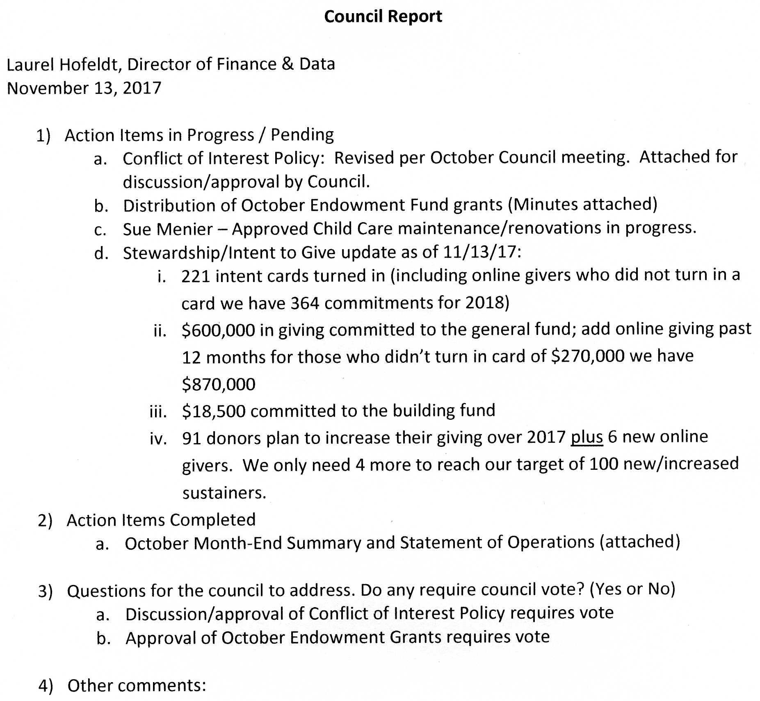

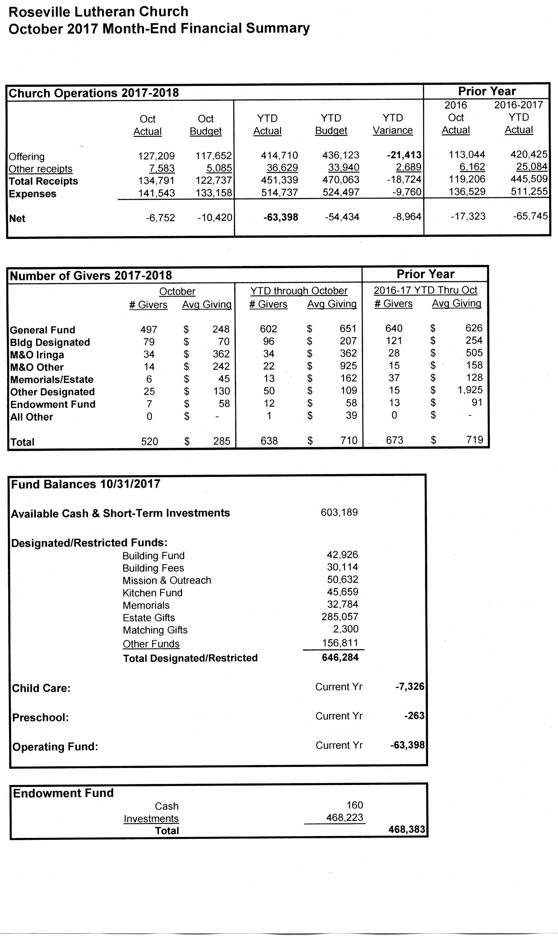
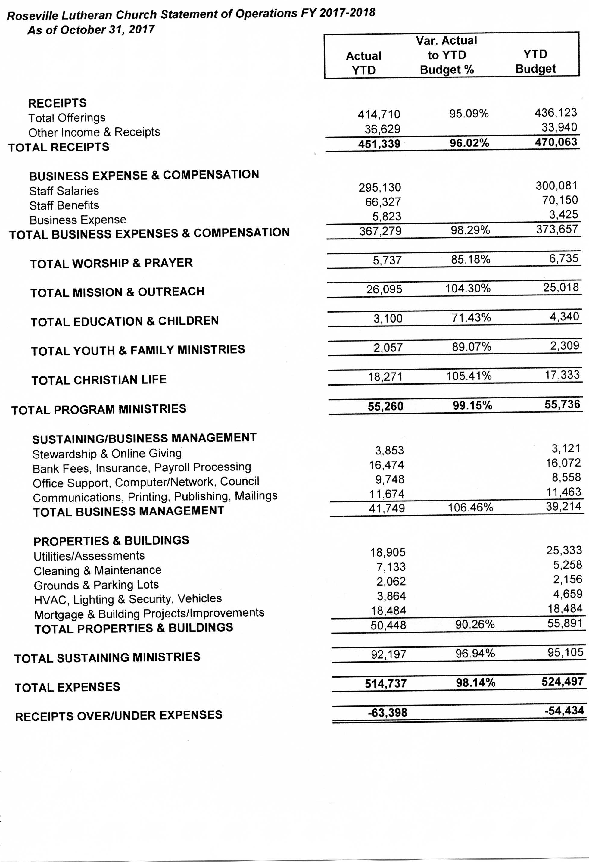
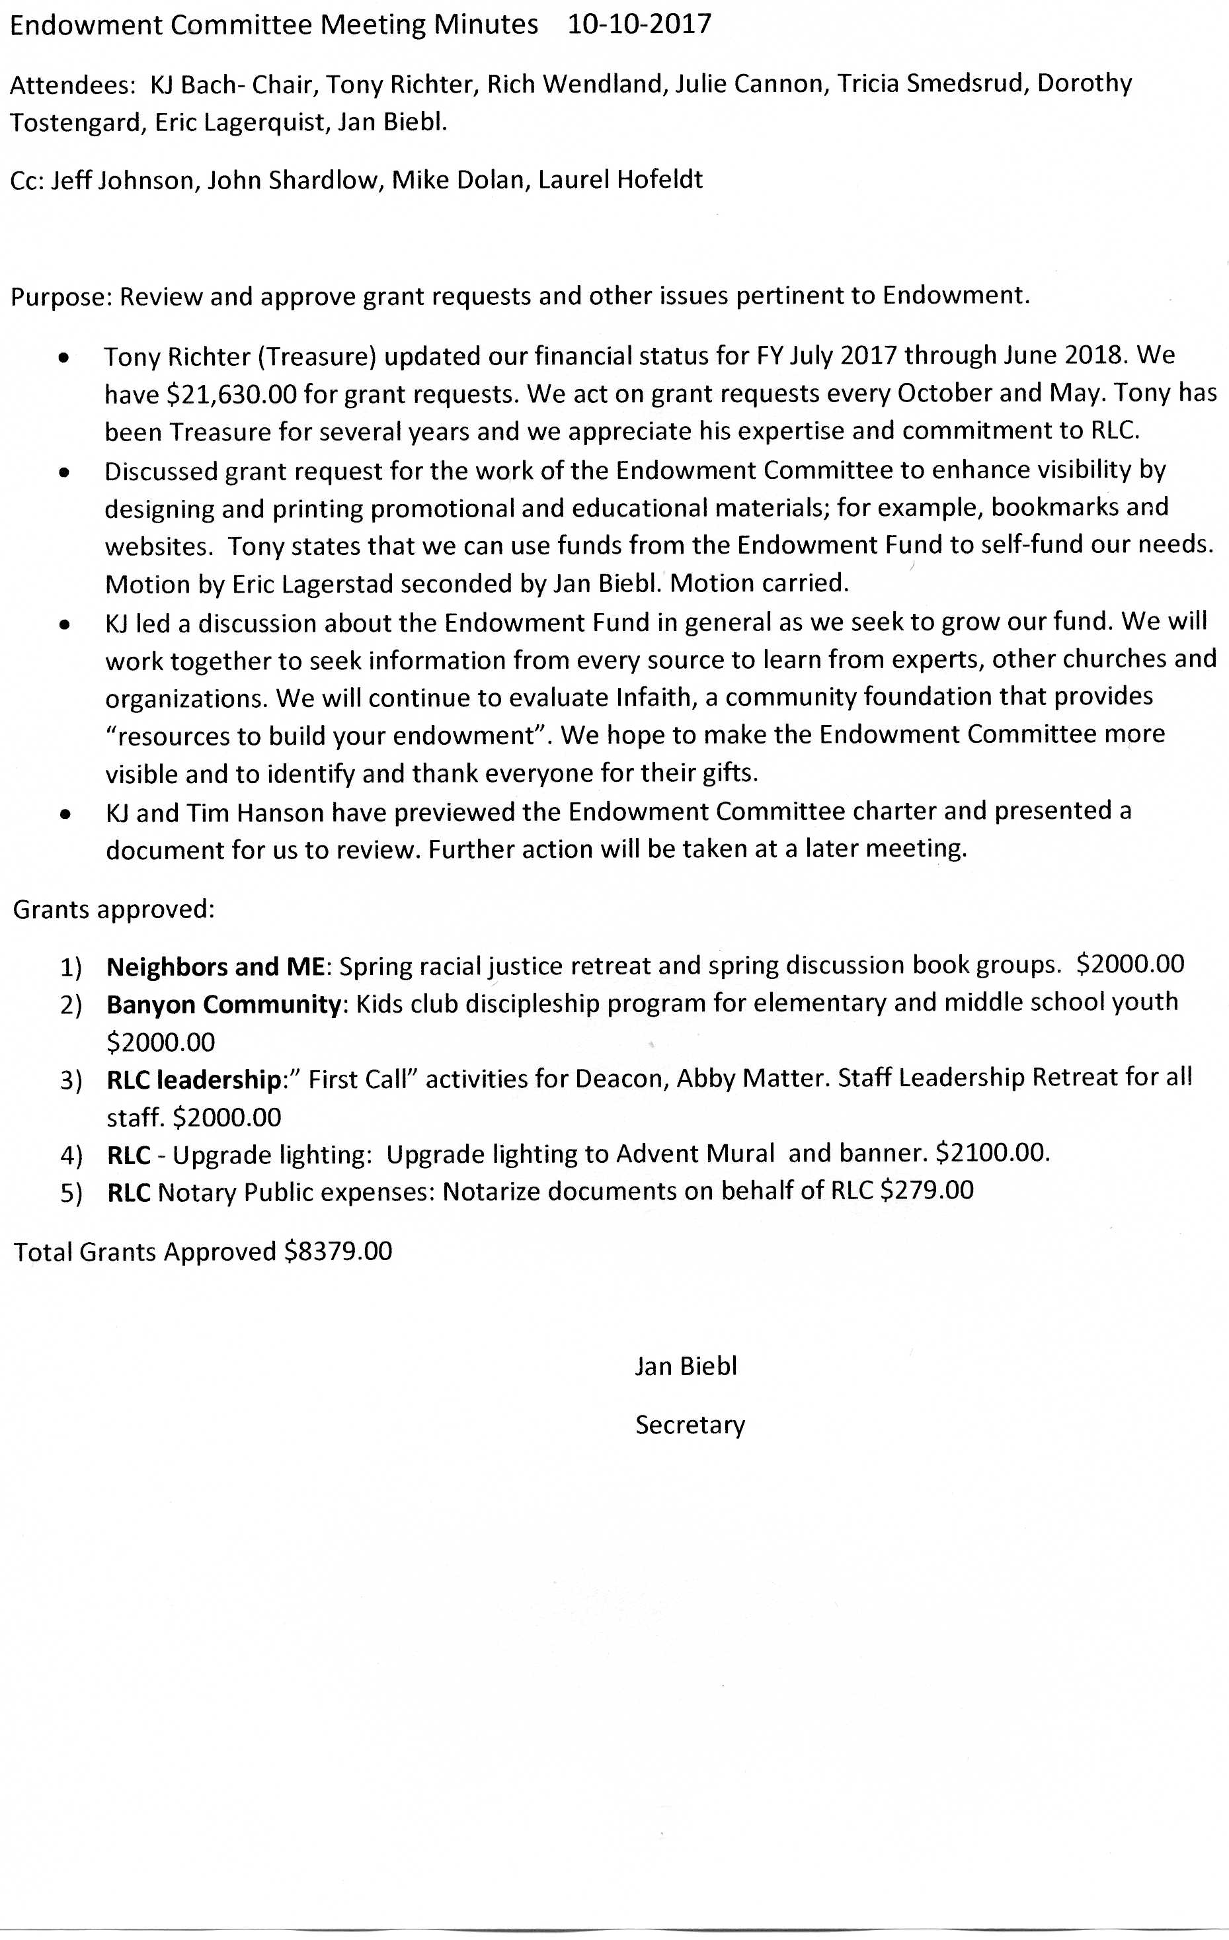
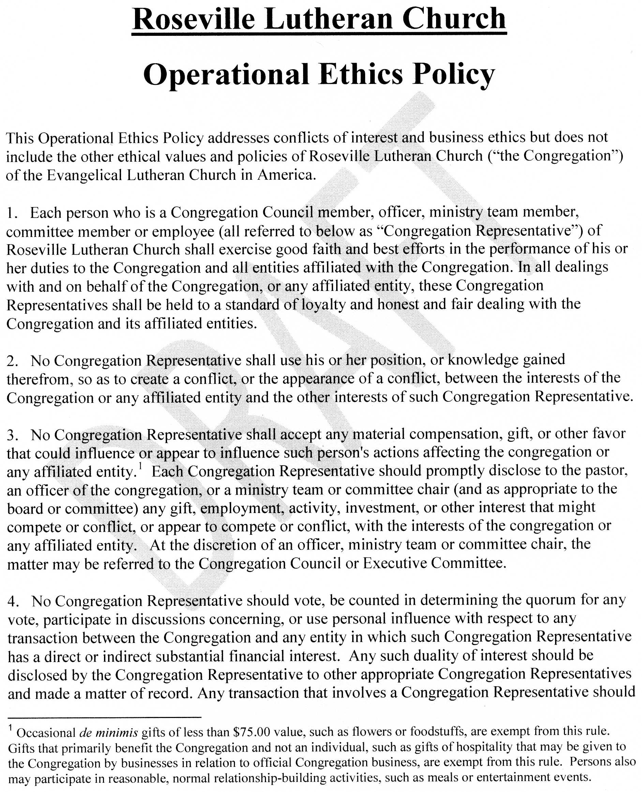

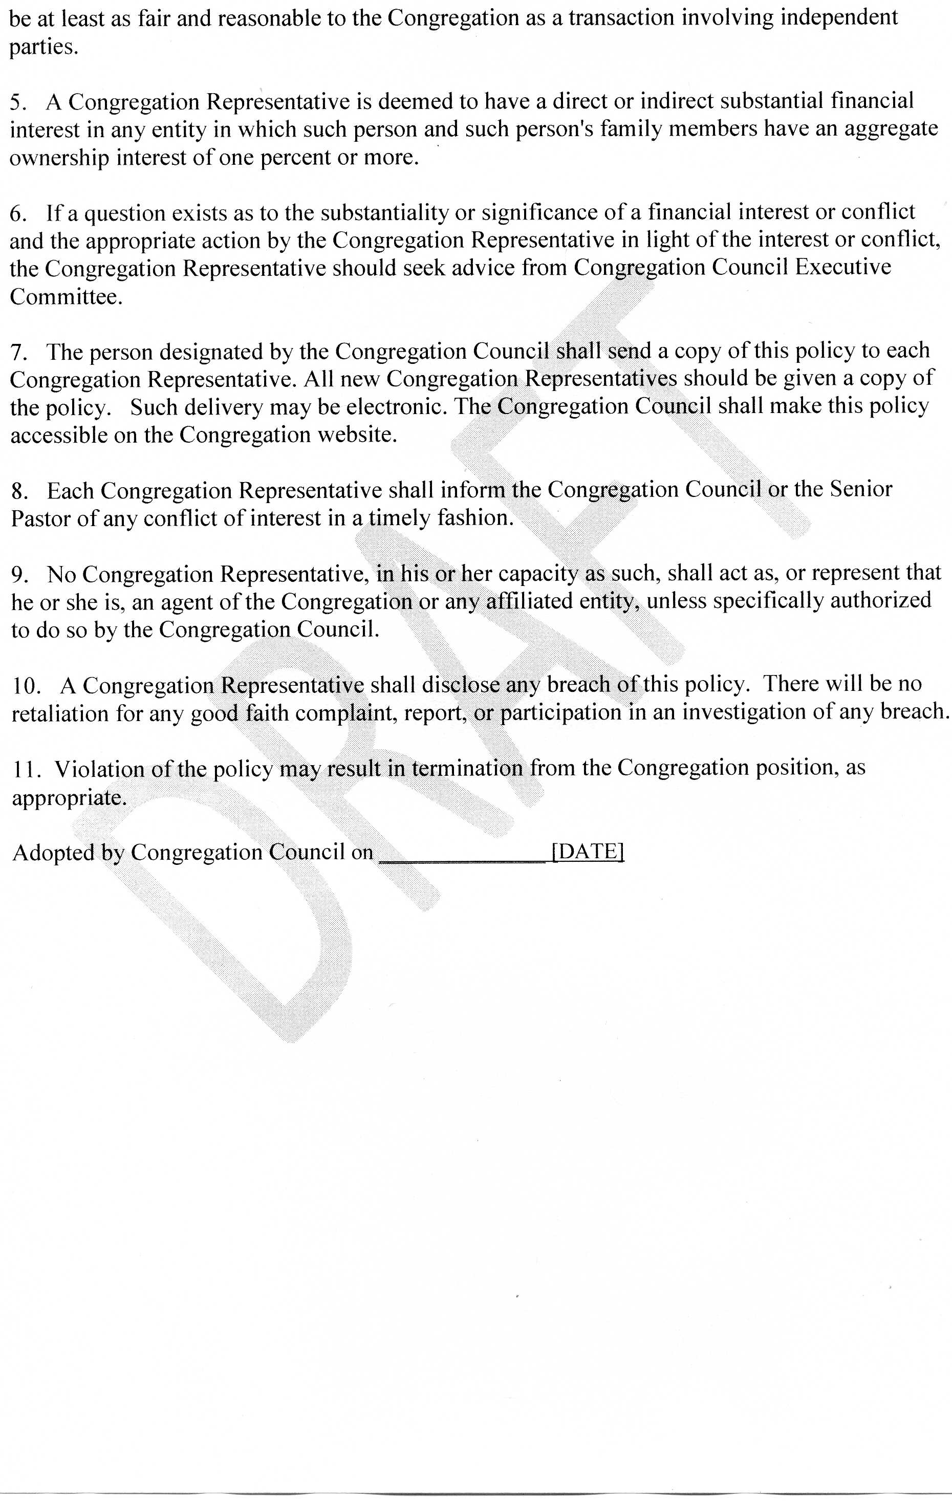

Children’s Ministry Update
November 2017
Council Liaison: Joe Zeigler

Recommendation to Council
Assign a task force whose mission is to ensure our kids have classroom and activity spaces that are conducive to the mission of Children’s Ministry.

Rationale
There is no program at Roseville Lutheran Church more aptly named than Cornerstone. Our youth programs connect with young families, which is essential to the current and future health of this congregation.
Cornerstone consistently receives high marks from the parents and children involved. Children’s Ministry leadership is to be commended for their dedication and commitment to our kids and their families.
Over the years, Cornerstone has expanded into makeshift classrooms and cubicles that occupy RLC facilities from the north end to the south. These spaces are, in general, noisy, dimly lit, and lacking in tools to support teachers and students. Our facilities have no accommodations for the many special needs children in our congregation. Patching the leaky activity center roof is likely not sufficient to eliminate mold and indoor-air-quality issues.
For the long-term health of our children and this congregation, RLC must plan and build Cornerstone classrooms and activity spaces that are safe, comfortable, well-lit, and accessible.
In alignment with Council objectives for greener facilities, Cornerstone classroom renovations might include energy-efficient lighting, solar panels, high-efficiency HVAC systems, etc.

Next steps
Julie Hanson will lead a Council tour of Cornerstone activities and facilities to identify needs and opportunities. The tour will be during a 10:10 hour in January 2018. Date to be confirmed.

