Date: December 13, 2018
- Call to Order
Mike Dolan called the meeting to order at 7:00 pm

- Devotional / Shared Prayer
Beth Jacobson shared a devotional with the group.

- Establish a Quorum
  - Members present: Mary Peterson, Dave Werner, Beth Jacobson, Tom Lund, Stacy Nealy, Mike Dolan, Jessica Henry
  - Members absent: John Shardlow, Mike Tostengard
  - Others present: Pastor Sara Spohr, Laurel Hofeldt

- Approval of Agenda
With the correction of next council meeting date to January 17, 2019: a motion to approve the agenda was made by Beth Jacobson and seconded by Mary Peterson; it was approved unanimously.

- Approval of October minutes
A motion to approve the October minutes was made by Dave Werner and seconded by Mary Peterson; it was approved unanimously.

- Approval of November minutes
A motion to approve the November minutes was made by Jessica Henry and seconded by Beth Jacobson; it was approved unanimously.

- Monthly Reports
  - Finance
Laurel Hofeldt shared that November’s offering was very strong and pointed out that strong offerings are common for this time of year. Highlights from her report included that there are nine new online sustaining families as a result of the fall efforts, the external audit is now complete, and a written report from the audit will be forthcoming; Laurel recommended performing another external audit in 3-5 years. Her full monthly report begins on page 4.
  - Staff
      - Pastors
        - Senior Pastor – Pastor Lauren Wrightsman
Pastor Lauren’s written report can be found on page 7.
A motion to approve annual meeting date of September 22, 2019 was made by Mary Peterson and seconded by Stacy Nealy; it was approved unanimously.
        - Associate Pastor – Pastor Sara Spohr

      - Church Administrator – David Booms
The full monthly report from Dave and his team begins on page 8.
        - Project Home Interim Use Permit
The City of Roseville’s Planning Commission recommended unanimous approval of our interim use permit for Project Home; their recommendation will go to the City Council on January 7. Mike Dolan plans to attend this meeting. If the City Council approves the permit, it will be valid for five years.
        - Status of campus maintenance issues. Demolition of Activity center ceiling, other
These details are available in Dave’s full report.

- Strategic Planning: Task Force Updates
        - Worship and Music
This task force will resume meetings in January. Conversation topics will include:
          - Wednesday Advent services
          - Organ discussion
        - Mission and Outreach
No additional updates to share since Council’s November meeting.
        - Campus Improvements
          - The LED lighting project is moving forward as planned.
          - Ceiling tiles from the perimeter of the Activity Center were removed with the help of a team of volunteers on December 8. The internal structures were examined for water damage and potential mold growth. Only a few areas required treatment.

- Committee Reports
    - Mission & Outreach
Tom Lund reported that this committee met on 12/5/18; the group is continuing to establish its new structure and is focusing effort and support toward the needs of local organizations.
    - Stewardship
Stacy Nealy shared that the Mission Advancement Team will meet in January and dive into work on the pRAISE RLC effort that will come in the spring.
    - Children-
Mary Peterson summarized the success of the Children’s Christmas Program; her full written report can be found on page 10.
    - Youth & Family
In Mike Tostengard’s absence, Pastor Sara Spohr shared that the Youth & Family group is preparing to search for a new youth director, as Michael Jordan will pursue his studies at Luther Seminary full time beginning in August 2019. A survey was distributed to program participants (youth, parents, and volunteers) during the week of December 10. The team will use the survey responses to determine what type of candidate would be the best fit for the position.
    - Adult Education
Dave Werner met with the Adult Education Committee on 12/13/18; he shared that the group is continuing to schedule educational sessions into 2020. They need to know the date for the One Worship in Fall 2019. Due to scheduling conflicts, the Adult Education group needs to reschedule their meeting with Mission Advancement to a date in February 2019.
    - Christian Life
Beth Jacobson shared that she did not have any updates to report from this team. There is a list of upcoming events in the current issue of The Table.
    - Nominating
Jessica Henry reported that the Nominating Committee will begin formal work in January. In the meantime, she will work with Dave Booms to compile a list of all of the positions that must be filled.
HOMEWORK ASSIGNMENT: Jess asked Council Members to brainstorm individually about people who would be good additions to RLC’s lay leadership group; Council Members will each be asked to suggest a name when the Council meets in January.

- Items for Discussion
No items were raised for discussion.

- New Business (Action Items): 2019 Pastoral housing allowance
Laurel shared a brief explanation of this action item: pastors can designate a portion of their salary to be a housing allowance. Because this designation has tax implications, the IRS requires the Council to approve the housing allowance.
A motion to approve the 2019 pastoral housing allowance was made by Tom Lund and seconded by Dave Werner; it was approved unanimously.

- Upcoming dates
January 17, 2018 - location will be determined soon. This evening will be twofold:
  - 6:30 pm CCC event
  - 7:30 pm Council meeting

- Adjournment
A motion to adjourn the meeting was made by Stacy Nealy and seconded by Jessica Henry; it was approved unanimously.

- Closing Prayer
Pastor Sara Spohr led the Council in the Lord’s Prayer.

Council Report

Laurel Hofeldt, Director of Finance & Data
December 13, 2018

- Action Items in Progress / Pending
    - External audit with Georgia Akins, CPA of Akins Henke & Company. Final report expected in January 2019
    - Fall Stewardship (Mission Advancement) campaign - 9 NEW Sustainers enrolled in online giving, the majority being CYF families.
    - Initial planning for spring campaign (pRAISE RLC!) – Mission Advancement Team
    - Mission Advancement is laying the groundwork to introduce a major giving program at RLC.
- Action Items Completed
  - November Month-End Summary and Statement of Operations are attached.
    - Total Offering is $15,000 below budget. This includes $38,000 of the budgeted Special Asks to Budget ($148,000 for the year), meaning general offering is $21,000 over budget. This is due to receiving several annual gifts (stock, IRA qualified charitable distributions) this month from donors who gave those gifts in a different month last year.
    - Expenses are $10,000 below budget.
    - Actual net operating deficit of $58,204 is only $711 greater than our budgeted net deficit of $57,493.
  - Giving Statements went out the first week in December including a letter to consider an additional gift to RLC for the calendar year-end.

- Questions for the council to address. Do any require council vote? (Yes or No)
  - Motion and approval of 2019 Housing Allowances to be noted in December minutes.

- Other comments:

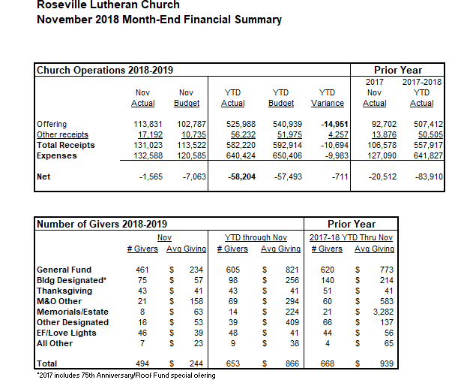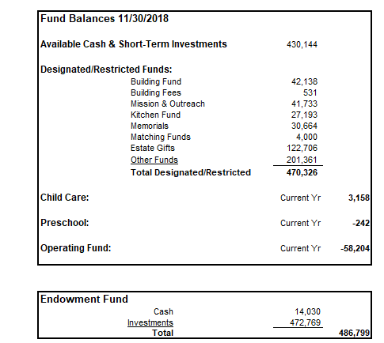

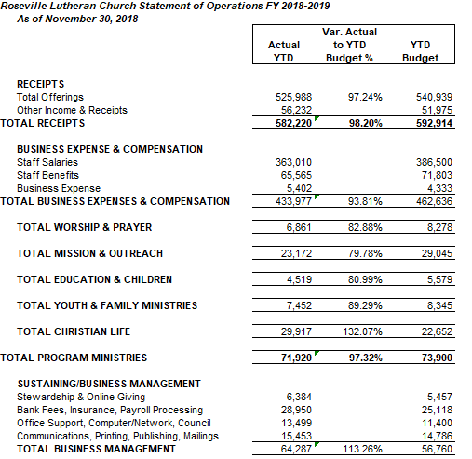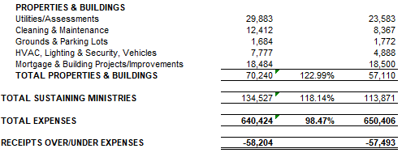

Council Report
Senior Pastor, Lauren Wrightsman
December 2018

1) Committees, Councils and Chairs – Thursday, January 17 – NEXT MEETING
The next one is scheduled for Thursday, January 17 @ 6:30 Location yet to be determined but may be at Central Park Elementary. Council meeting will begin at 7:30 p.m.
2) Saturday evening worship closure / Advent Wednesday Worship
The Saturday evening service ended officially on November 17th. Advent worship began Wednesday, November 28th. We have seen about 50-60 people at this evening service
3) Worship and Music Task Force
This task force will resume its work in January. We will be looking at three areas:
- Engagement: Especially at 11:00 – is this a “seeker service”
- Mid-week worship: what could we consider as an alternative
- Worship environment: Instruments (organ especially) sound, video, lighting
4) One Worship – Sunday, May 19th
- One Worship scheduled for May 19th.
- This will be a service of rejoicing for our youth and children’s programs, our graduating seniors, as well as a kick off for pRAISE RLC – our end of year financial giving challenge

Council and CCC meeting dates 2018 - 2019:
Thursday, January 17
CCC event 6:30 - 7:30 p.m.
Council @ 7:30 p.m.
Thursday, February 21 @ 7:00 p.m.
Thursday, March 21 @ 7:00 p.m.
Thursday, April 11 @ 7:00 p.m.
(Thursday, April 18 is Maundy Thursday)
Thursday, May 16
CCC event 6:30 - 7:30 p.m.
Council @ 7:30 p.m.
Department Name: Administration

New Business:
- Reviewing rental fees for 2019
- Three new building rentals for Spring 2019
- Participating in Task Force on the Church-wide ELCA’s “Philosophy of Benefits”
- USPS has proposed a 3 cent hike in metered mail, from 47 to 50 cents

On-going:
- Awaiting results of application to the Center of Environment & Energy
- Completing application to Biz Recycling
- Looking for new bids on a Wi-Fi hub

Department Name: Properties, Bruce Pelava, Campus Manager
NEW BUSINESS
- Nothing new at this time

ON GOING
- All towel and soap dispensers have been converted to touch free operation.
- Flooring work on main level ramp completed.
- Flooring on ramp in Social Hall completed.
- Activity Center ceiling
  - Old border ceiling has been removed (very little mold ...a spray was applied to kill it)
  - Replacement ceiling work started 12/11/18 will take about 2 days.
- Sheet metal work being installed on roof. Nearly completed.
- Parking lot repairs have been completed.
- Reducing clutter with dumpster on site.
- We clarified our parking lot salting program with the plowing company
- The Mazda pickup truck was sold and has been removed.
- A meeting for window replacement was cancelled. Thus nothing to report.
- Mural to be taken down January 7-9

NO ACTION REQUIRED OR RECOMMENDATIONS TO COUNCIL AT THIS TIME

Department Name: Communications, Daniel Pederson, Communications Manager
Summary of activities that have occurred since the last monthly report.
- Dec-Jan-Feb TABLE Newsletter Out (next deadline is Feb. 1 for March-April-May).
- Advent/Christmas worship and event support in progress/well in hand.
- Website and FB updates, new scheduling of items for FB.
___________________________________________________________________________________
Summary of upcoming events, or issues that the Church Council should be aware of:
- Working on future videos… stories of RLC, supportive of Mission Advancement, as well as building community through getting to know others, and what folks are doing at RLC and in the community.
- Work on refining Mission Advancement/Stewardship on the website to align with the name change. Also investigating calendar options...ServiceU and Shelby coordination, optimizing for mobile devices.

Department Name: Hospitality, Connie Marchio, Hospitlity Manager
Summary of activities that have occurred since the last monthly report.
Since the last report that was sent, Hospitality has served an estimated number of 1,194 guests, due in part to; larger than normal funerals, Vets Day service turn-out, and other outside groups. This was the first year of the Candy Cane breakfast for the children and their special adults. This was a very popular event and did sell out. It was a very interactive event for all to enjoy. I recommend this event to continue yearly. I would like to make an application to Endowment, about having the Candy Cane breakfast next year with the opportunity to invite children and their families that cannot afford to come
Summary of upcoming events, or issues that the Church Council should be aware of:
The next large events that will occur will be Prime Time, the monthly ADK meeting and the big Christmas Festival concert (Where we will serve all different types of dessert and beverage items).
I would like to have a conversation with endowment, about having the Candy Cane breakfast next year with the opportunity to invite children and their families that cannot afford to come

ROSEVILLE LUTHERAN CHURCH
MONTHLY MINISTRY TEAM AND COMMITTEE LIAISON REPORT

Date of Church Council meeting: __12.12.18_____________________________
Committee or Ministry Team Name: _Children’s ministry___________________________
Prepared By: _Julie Hanson/Mary Peterson_________________________________________
Date of the last meeting: ______________________________________

Summary of topics discussed, and activities that have occurred since the last meeting:
- Parents Night Out on 11/30 which welcomed 32 kids as parents had a night off- proceeds went to the youth scholarship fund for kids going to camp and on trips
- Candy Cane Breakfast was 12/1 with 80 guests who enjoyed a fun breakfast and activities for kids ages 2-10 and the special adults in their lives.
- 12/9 Christmas program with over 160 participants including kids. leaders, band, lighting and props people, actors and 5th and 6th grade Christmas Choir.
- 12/16 One more week of regular programming and then a 2 week Christmas break.
Summary of upcoming events, or issues that the Church Council should be aware of:
- January includes our Serve Sunday to benefit Bridging, where we build 50 dressers and collect blankets, make kitchen linen bundles and cleaning kits for the clients of Bridging.
- Fleece Blanket kits will be handed out Sunday 12/30 and 1/6 for people to make the at home and bring them back on 1/13 for Bridging
Does the group have any questions, or concerns to bring to the Council? Is there anything the Council, or staff can do to assist the group?
- Not at this time.

