Date: January 17, 2019
- Call to Order
John Shardlow called the meeting to order at 7:40 pm

- Devotional / Shared Prayer
Mike Dolan shared a devotional with the group.

- Establish a Quorum
  - Members present: Mary Peterson, Mike Tostengard, Dave Werner, Beth Jacobson, Tom Lund, Stacy Nealy, John Shardlow, Mike Dolan, Jessica Henry
  - Members absent: none
  - Others present: Pastor Lauren Wrightsman, Pastor Sara Spohr, Laurel Hofeldt, Dave Booms

- Approval of Agenda
With the addition of a new business item allowing for the discussion of a Development Strategy Task Force, a motion to approve the agenda was made by Mike Dolan and seconded by Dave Werner; it was approved unanimously.

- Approval of December minutes
A motion to approve the December minutes was made by Beth Jacobson and seconded by Dave Werner; it was approved unanimously.

- Monthly Reports
  - Finance
Laurel Hofeldt shared she has been working on closing the calendar year. She indicated that Christmas and year end gifts were consistent with last year, updates to Intent to Give amounts are complete, and staff raises were implemented as of January 1. Her full monthly report begins on page 4.
  - Staff
      - Pastors
        - Senior Pastor – Pastor Lauren Wrightsman
Pastor Lauren’s written report can be found on page 7.
She invited retrospective conversation about the two completed Council-Chairs-and Committees (CCC) events – Council members were very supportive of the events and appreciated the chance to interact with so many lay leaders in one place.
        - Associate Pastor – Pastor Sara Spohr
Pastor Sara’s written report can be found on page 8.
She highlighted that Council members are asked to attend Confirmation on February 6 from 7:00-8:00 pm; they will join 9th grade confirmation students for a discussion about leadership and involvement in the church.

      - Church Administrator – David Booms
Dave reminded Council members that the deadline for the next issue of the Table is coming up; please talk to your committees about submitting content. He also indicated that there are more and more outside groups interested in using RLC’s facility. The full written report from Dave and his team begins on page 9.
        - Completion of Roof projects
Costs were slightly under budget.
        - Project Home Interim Use Permit
Roseville’s City Council followed the Planning Commission’s recommendation and approved RLC’s interim use permit for Project Home; the permit will be valid for five years.
        - Status of campus maintenance issues
Development of a Green Team is underway – any suggestions for a team leader should be shared with Dave. Additional maintenance details are available in Dave’s full report.

- Strategic Planning: Task Force Updates
        - Worship and Music
This task force will resume meetings in January. Conversation topics will include:
          - Wednesday Advent services
The meeting for this topic will be rescheduled.
          - Organ discussion
Martha Mutch and KJ Bach will present on the current state of the organ at a Worship & Music Task Force meeting. This will kick-off a careful and deliberate task force conversation about the role of the organ in worship at RLC and the options available.
        - Mission and Outreach
This team continues to work through their transition and evaluate its partner organizations.
        - Campus Improvements
          - LED lighting
A date will be set for Premiere Lighting to bring an installation team, likely within the next month.

- Committee Reports
    - Mission & Outreach
Tom Lund’s written report can be found on page 11.
Tom Lund reported that this committee met on 12/5/18; the group is continuing to establish its new structure and is focusing effort and support toward the needs of local organizations.
    - Stewardship
Stacy Nealy shared that the Mission Advancement Team met on January 15 and dove into work on the pRAISE RLC effort that will come in the spring.
    - Children
Mary Peterson will meet with this committee next week. Her full written report can be found on page 12.

    - Youth & Family
Mike Tostengard reported that the youth director job description will be reviewed for any necessary modifications prior to the position being posted. Pastor Sara shared a high-level overview of the survey responses that were collected to help guide the Youth & Family Ministry Team in the candidate selection process – the responses were overwhelmingly positive.
    - Adult Education
Dave Werner will meet with the Adult Education Committee on 2/14/18; he shared that the group is continuing to schedule educational sessions into 2020.
    - Christian Life
Beth Jacobson’s written report can be found on page 13.
    - Nominating
Council Members suggested many names of people whom the Nominating Committee should consider for lay leadership positions; additional suggestions are welcome – please share them with Jessica Henry.

- Items for Discussion
  - Continued budget discussion: formation of RLC Development Task Force
Pastor Lauren summarized the role of this task force will be to explore and evaluate stewardship practices, endowment structure, mission and outreach, and leadership to create a broad discussion of RLC’s stewardship needs. A background document can be found on pages 14-16.
A motion to implement this task force was made by Mike Dolan and seconded by Stacy Nealy; it was approved unanimously.
  - Interim youth director transition staffing
Pastor Sara requested $3,700-4,200 of funding to allow a new youth director to be hired before Michael Jordan leaves; this would allow Michael to overlap with the new youth director for a few months. John Shardlow suggested this may be an opportunity for a special ask. The interviewing team is planning to meet with candidates at the end of March and into April.

- New Business (Action Items):
No new business action items were raised.

- Upcoming dates
The next Council meeting will be held on February 21, 2018 at 7:00 pm.

- Adjournment
The meeting was adjourned at 8:35 pm.

- Closing Prayer
Pastor Lauren Wrightsman led the Council in the Lord’s Prayer.
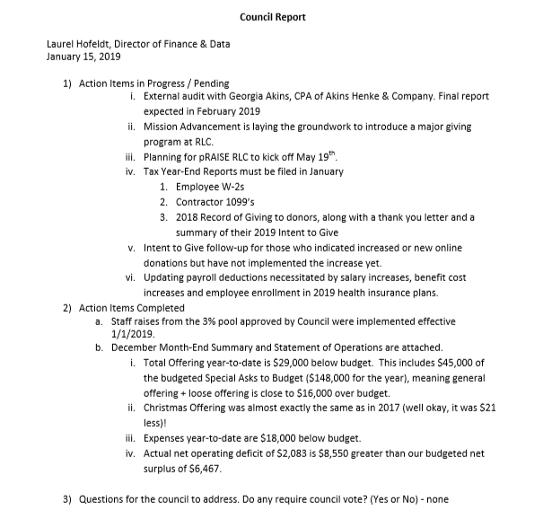
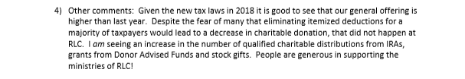
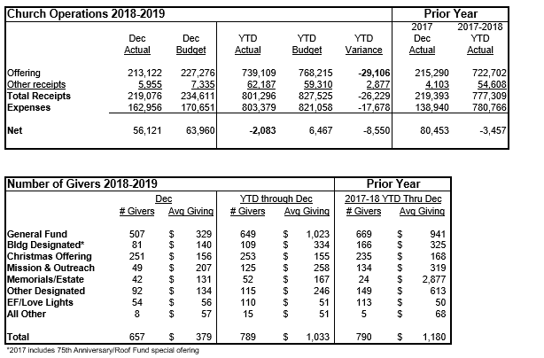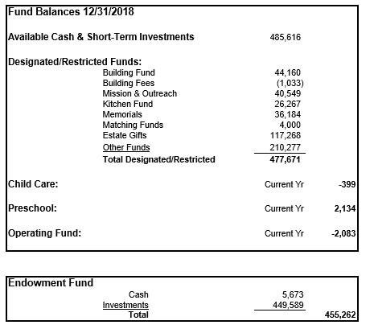
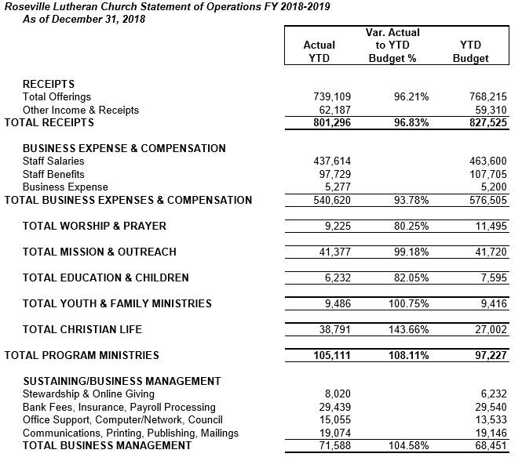
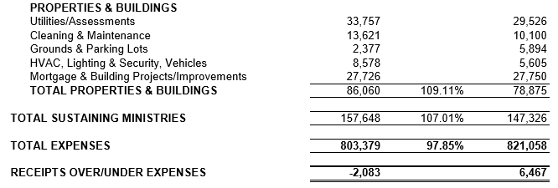

Council Report
Senior Pastor, Lauren Wrightsman
January 2019

1) Committees, Councils and Chairs – Thursday, January 17 – NEXT MEETING
Please join us at 6:30 in the Social hall for the CCC meeting. Council will begin at 7:30 p.m. in room 40. Pizza will be served.
- Mission and Outreach will be presenting about this important area of ministry
- Mission Advancement will also have a short presentation
- Next CCC event is Thursday, May 16
CCC event 6:30 - 7:30 p.m.
Council @ 7:30 p.m.
2) Advent Wednesday Worship
We averaged between 50 and 60 people during our four Wednesday worship services during the season of Advent. We will plan on continuing this next advent season
3) Worship and Music Task Force
This task force is resuming its work and is focusing on three areas:
- Engagement: Especially at 11:00 – is this a “seeker service”
- Mid-week worship: what could we consider as an alternative
- Worship environment: Instruments (organ especially) sound, video, lighting
4) One Worship – Sunday, May 19th
- One Worship scheduled for May 19th.
- This will be a service of rejoicing for our youth and children’s programs, our graduating seniors, as well as a kick off for pRAISE RLC – our end of year financial giving challenge
5) Major gifts
The Mission Advancement is working with a group of dedicated individuals to assist in forming a plan that would help us communicate our financial needs and resources. I am excited to work with this group of dedicated volunteers.
Council and CCC meeting dates 2018 - 2019:
Thursday, February 21 @ 7:00 p.m.
Thursday, March 21 @ 7:00 p.m.
Thursday, April 11 @ 7:00 p.m.
(Thursday, April 18 is Maundy Thursday)
Thursday, May 16
CCC event 6:30 - 7:30 p.m.
Council @ 7:30 p.m.

Council Report
Staff Member name: Pastor Sara Spohr
Date: January 2019
Action Items in Progress / Pending
- Mission and Outreach - We have been emphasizing our local focus within our church communications, projects, and volunteer opportunities for the last 6 months and I see some really good fruit as a result. Our team is working with this focus and is more easily able to say no to projects that pull us away. Our people are starting to regularly hear about the key areas we are serving and the opportunities they have to get involved. We focused our sharing trees this year on local partners and the response was phenomenal. We had more coat, snow pants, and boots to give to Central Park than they needed, the excess stayed local too and went to the Fairview Community Center right here in Roseville. We have lined up all of the January Sunday Adult Education hours to emphasize these local partnerships. During the week of January 7-13, we built 56 dressers for bridging and delivered more than 150 blankets as well as cleaning kits and kitchen linens. We are making an impact!
As we look ahead, we are now signing up volunteers to serve with Project Home in February, we are preparing for another Serve Sunday in March to benefit Keystone, our youth will be sharing information and fundraising opportunities for their June service learning trip to Slovakia, and the team from Feed My Starving Children will be gearing up for a week of packing meals. The Our Neighbors and Me team also has an exciting lineup of Spring book studies and educational opportunities. We are moving forward!
- Children, Youth, and Family Ministry - Our staff is working hard and working faithfully. There are a lot of events in January and February and the staff we have is organized, communicates well, and makes sure that things are done with purpose and meaning. It is an honor to work with such dedicated people. If you cross paths with Julie Hanson, Michael Jordan, or Abby Matter, you might thank them for their ministry efforts on behalf of young people and their families at Roseville Lutheran.
In October I requested an additional $3700-4200 increase to our budget $3700-4200 increase to our youth ministry personnel budget. It would aid in our transition of Youth Directors to be able to bring a new staff person on full time for our busy summer, to learn the summer routine and be mentored by Michael. Michael has a wealth of information, he is organized and willing to train in a new person. Please consider this request to aid our search team in the hiring process.
Council night at Confirmation - Wednesday February 6, 2019, 7:00 - 8:00 pm. Please put this date on your calendars.
- I am working with a team of about 40 writers to write, edit and produce a Lenten Devotional booklet. This year we will be reading through the book of Matthew and reflecting on the impact these stories and texts have on our lives. Please get a copy or sign up for the daily emails and join me in giving thanks for a great group of writers so willing to share the faith with others.
- Women’s retreat. I have been working with a small group of women to plan and implement a women’s retreat for Saturday February 23, 9-Noon here at Roseville Lutheran. This will be a great morning for fellowship and fun, but also spiritual growth and mutual support. I’m excited about opportunities like this for us to strengthen our connections with one another.
Department Name: Communications
Prepared By: Daniel Pederson, Communications Manager
Date : January 7, 2018
Summary of activities that have occurred since the last monthly report.
- Advent/Christmas worship and event support completed.
- Scheduling of items for FB and Website updates.
Summary of upcoming events, or issues that the Church Council should be aware of:
- Looking ahead to prep for “pRAISE RLC” with active efforts beginning at January 13 meeting.
- Next TABLE deadline is Feb. 1 for March-April-May.
- Working on promotional materials/video? for Hospitality ministry.
- Working on future videos:
  - For Mission Advancement/Endowment/Finance (regarding gift used for roof project).
  - Interviewing a member about their giving, being an online sustainer.
  - Hospitality
  - Upcoming support of “pRAISE RLC”
*************************************************************************************
Department Name: Hospitality
Prepared By: Connie Marchio, Hospitality Manager
Date: January 8, 2018
Summary of activities that have occurred since the last monthly report.
- Since the last report that was sent, Hospitality has hosted the post-Christmas concert gathering that served approximately 565 guests.
Summary of upcoming events, or issues that the Church Council should be aware of:
- We are now scheduling volunteers for the upcoming Lenten suppers. This year it will be a bit different as I am adding on Ash Wednesday, as it a well-attended service night.
- I have set up a few tours for outside events to come to Roseville Lutheran church for their conferences and seminars, I feel we have a lot to offer and should utilize the space and catering opportunities to them.
- I will be starting to put together a menu selection and rental space brochure to pass out to guest that come to church.
*************************************************************************************

Department Name: Building & Grounds
Prepared By: Bruce Pelava, Campus Manager
Date: January 7, 2018
Summary of activities that have occurred since the last monthly report.
- Roof work and sheet metal work is complete. There will be a final inspection with Roof Spec and McPhillips roofing on Thursday 1/10/19. If everything passes, Roof Spec will get warranty papers and final billings to RLC.
- Activity Center ceiling work has been completed. Lights have been reinstalled.
  - A 30 yard dumpster was used to demolish the activity center ceiling. We were able to utilize it in disposing of much other unwanted junk.. ( A good investment)
- Ceiling tiles were replaced in the main floor south corridor. We now have extra tile available.
- The mural was taken down Monday January 7th. Worship center will be reset by Wednesday 1/9/19 evening.
Summary of upcoming events, or issues that the Church Council should be aware of:
- We will finish replacing the lights in the center of the Worship Center with LED fixtures on Wednesday 1/9/19.
- All funding has been approved by CEE so we can proceed with the lighting project. Premier electric has been instructed to order materials.

A Personal Reflection...

I would like to recognize and thank all of the volunteers who helped installing and removing the Mural. Without their help and knowledge I could not have completed the task.
I want to give a BIG THANK YOU to MIKE DOLAN for his help, guidance and patience (it was invaluable to me) in assisting with the work and with gathering manpower to help with the Mural.
I want to Thank KJ Bach for helping to organize the removal of the ceiling in the activity center.
ROSEVILLE LUTHERAN CHURCH IS BLESSED TO HAVE PEOPLE LIKE THESE WHO VOLUNTEER AND GIVE SELFLESSLY TO ASSIST IN THE WORK OF THE CHURCH.
I humbly thank them.

Bruce Pelava
Campus Manager Roseville Lutheran Church

ROSEVILLE LUTHERAN CHURCH
MINISTRY TEAM AND COMMITTEE LIAISON REPORT
January 17, 2019
MISSION & OUTREACH
Prepared By: TOM LUND
Date of the last meeting: January 8, 2018
Summary of topics discussed, and activities that have occurred since the last meeting:
- Keystone Food Drive – Soup and Soap, Warm Tummies and Toes Sock drive for Dorothy Day, and the Christmas Sharing Tree for Central Park Elementary, Project Home, Bridging and Sheridan Story were all successful. We have a very generous congregation.
- . Bridging Dresser Build and kitchen packages on January 13.
- 10:10 Hour presentations – Jan. 6 – Central Park Elementary, Jan. 20 – Sheridan Story, and Jan. 27 – Keystone.
- We have volunteers for both Central Park bingo night and student council packing for Sheridan Story.
- Volunteers needed for Central Park School Carnival on March 22.
- February table articles covering Project Home, Bridging, Central Park School Carnival, Our Neighbors and Me, FMSC and Sheridan Story.

Does the group have any questions, or concerns to bring to the Council? Is there anything the Council, or staff can do to assist the group?
NOT AT PRESENT

ROSEVILLE LUTHERAN CHURCH
MONTHLY MINISTRY TEAM AND COMMITTEE LIAISON REPORT

Date of Church Council meeting: 1-17-19
Committee or Ministry Team Name: Children’s ministry
Prepared By: Julie Hanson, Director of Children’s Ministry
Date of the last meeting: Upcoming CM Advisory Board Meeting scheduled for January 22, 2019
Summary of topics discussed, and activities that have occurred since the last meeting:
- Cornerstone Christmas program was Dec 8th and attendance was excellent, both kids participating and congregation.
- Serve Sunday was last Sunday, Jan 13th, assembling 56 dressers total (FLOCK and Confirmation students also built dressers during the week), 60 kitchen linen bundles and 60 cleaning kits were assembled, and approximately 150 blankets were donated. Using Thrivent Action Grants, fleece blanket kits were purchased and handed out to the congregation on 12/30 and 1/6 to be completed at home and returned to RLC on 1/13. This was very successful. We handed out ___ kits, twice as many as last year and all were taken before the 11:00 service on 1/6 was over. Our partnership with Bridging is strong and they are very appreciative of all the support and volunteer hours that RLC gives them.
Summary of upcoming events, or issues that the Church Council should be aware of:
- Upcoming Events: Talent Show on 1/27 asking all members of the congregation to participate! Looking for 60 acts in 60 minutes to showcase something they do well- what can you do to participate? Do you do bird calling? Creative writing? Paper airplane folding? Show us 60 seconds of your amazing talent! Sign up is online, or a paper sign-up sheet is on the Welcome desk and CYF desk.
- This is a Garage Sale Year- Garage sale will be May 3rd and 4th. Collection of items will begin April 22nd. Many volunteers are needed to organize and help at the sale. If you can help pick up donated items, sort things, be at the sale to direct traffic, etc please contact Julie Hanson.
Does the group have any questions, or concerns to bring to the Council? Is there anything the Council or staff can do to assist the group?
Now that the Activity Center is water-proof, we will be looking at ways to upgrade the acoustics and sound, etc. in that space. This will not happen immediately, but hopefully before next fall. Just an FYI.

ROSEVILLE LUTHERAN CHURCH
MONTHLY MINISTRY TEAM AND COMMITTEE LIAISON REPORT

Date of Church Council meeting: __January, 17th, 2019_____________
Committee or Ministry Team Name: ___Life Ministry_______________
Members Present: __Roxanne, Nancy, Brad, Janet, Jane, Trish (staff liaison), Beth (council liaison)___
Prepared By: ____Beth Jacobson__________________
Date of the last meeting: __January, 8th 2019__________

Summary of topics discussed, and activities that have occurred since the last meeting:
- Group discussed the upcoming Hopp’n Helpers and Swing Dance events in detail and anything that is still needed to be done for each event. We also confirmed final decisions as well as specific tasks/help from each member for set-up.
- Any extra volunteers to oversee stations of Hopp’n Helpers would be greatly appreciated (1-2 ppl more would make a difference). Suggested donation requested for admittance will benefit Project Home.
- The Swing dance event is meant to be an all-ages event and not necessarily overly romantic, but the group is looking into whether some child care would be helpful for parents of young children. Nancy will be asking Michael Jordan about any youth volunteers. Group also hopes that in general, youth would be interested in coming to the event.
Summary of upcoming events, or issues that the Church Council should be aware of:
- Brochure of events through February is available since quite a few are taking place or continue from December.
- Upcoming include:
- Local author Nancy Koester discussing her book—Saturday, Jan. 19th
- Coffee and Canvas—Saturday, Feb. 2nd
- Restaurant Week is scheduled for April 7th-13th (just before the busy Palm Sunday/Easter weeks. An event notice and call for hosts will go out in the next Table publication.
- Next meeting scheduled for Feb. 5th at 6:30pm.
Does the group have any questions, or concerns to bring to the Council? Is there anything the Council, or staff can do to assist the group?

“Love God. Love your neighbor. A community united by grace.”

RLC Development Strategy Task Force
January 2019

Background
The RLC Mission Advancement Committee (Stewardship) has been operating as an “ad-hoc” committee of the congregation since 2013. Throughout the years this committee has given guidance, support and assistance to revenue generation at RLC by
- conducting fall annual financial sustainer campaign,
- conducting the fiscal year-end financial giving campaigns
- supporting other tactical fundraising campaigns conducted by other ministry teams.
The team has educated the congregation around the financial needs of the church to carry out the programs and ministry, that individual giving is the primary means to fund these financial needs. The team also tries to teach the congregation practical ways to incorporate giving to the church into individual member lives.

While the committee has been successfully meeting tactical goals, our revenue situation continues to be “surviving” not “thriving”. To move our church to “thriving”, the RLC Mission Advancement Committee requests that a Development Strategy Task Force (DSTF) explore and evaluate the current & future stewardship needs of the congregation at Roseville Lutheran Church and explore how these practices support and sustain our current vision and mission.

Purpose
The Development Strategy Task Force is to look at the current and future financial needs of Roseville Lutheran Church, identify all the possible revenue sources, and create a comprehensive and cohesive plan to create a sustainable funding plan for RLC.

Roles and Responsibilities
The Development Strategy Task Force will serve in an advisory capacity to the Roseville Lutheran Church Council. The task force will work collaboratively with staff, volunteers and committees responsible for the stewardship needs of our congregation. The current Mission Advancement team has background in both non-profit fundraising best practices, religious giving trends, as well as the history of stewardship over the last 7 years. They are available as subject matter experts if needed.

Core Values
- We are rooted in the Lutheran tradition and trust that the Holy Spirit calls and gathers us as a people of God.
- We affirm the importance of Christian stewardship in our daily lives: we are meant to live as generous givers, to be the hands and feet of Jesus in our communities and world.
- We aspire to the transformational power of Christian stewardship: With Christ at the center, we live in relationship with God, receiving with gratitude all we have from him, and releasing all we are to him for the blessing of others.
- As a body of Christ, we engage the members of the congregation to share and hear the Word of God and foster the expression of our mission and vision: “Love God. Love your neighbor. A community united by grace.”
- We affirm that when we commit resources (time and money) to the church, these resources are used to advance our mission and vision as a body of Christ.

Areas of Focus
- Explore and evaluate RLC’s current stewardship practices, staffing and communication regarding our ministry and financial needs.
- Designate areas of financial and stewardship practices that support our vision and mission and are to be sustained.
- Seek out opportunities to launch new initiatives and practices for stewardship and mission advancement.
- Designate areas in our stewardship and mission plans that need to be released.
- Create a vision of potential staffing and communication to insure continued growth in giving and stewardship practices, including an evaluation of our church constitution and supporting documents for Endowment, Mission and Outreach, etc.
- Present findings and suggestions to RLC council.

Key Deliverables
- List of Development practices that should be sustained and launched, e.g. Spring Campaign
- List of Stewardship practices that should be sustained and launched, e.g. Begin a basic budgeting class
- Comprehensive listing of current annual funding needs, capital needs, long term needs to sustain a high quality ministry (please include financial information, and timeline to raise funds)
  - For example: youth director is a need, it is part of our operating budget and is needed annually
- Link development practices to funding needs ; the spring campaign will be utilized in support of the youth director annually until 2021.
- Recommendations on how council, endowment, mission advancement/stewardship, and staff should be structured and coordinated to fundraise effectively
  - For example:
  - Council will run the spring campaign, mission advancement will advise
  - Endowment will seek funds for an endowed position

Timeline
The Mission Advancement Committee recommends convening a group of individuals to begin in March 2019. The committee will meet 2 times a month to evaluate, assess, discuss, and create a recommendation regarding the future needs of RLC focused on financial and stewardship stability. A report will be offered to the church council in August 2019 for their review.

Members
The Task Force will consist of the following members:
- Senior Pastor (staff)
- Associate Pastor (staff)
- Vice President of the church council
- Director of Finance and Data (staff)
- Endowment Committee member (1)
- Council Representative (1)
- Mission Advancement Committee member (1)
- Finance Committee member (1)
- Key congregational members (3)

